Coder Process Tip Sheet

Introduction
Streamline Health’s eValuator™ solution can help increase revenue certainty by substantially improving coding accuracy. This tip sheet will define the coder process within eValuator.

Coder Process
- The coders only respond to the encounters they receive and can only see the encounters that are reserved for them.

- The auditor marks a code as a query. This is done by selecting the question mark button found on the righthand side of the codes under the encounter. This will send the query on to the coder.

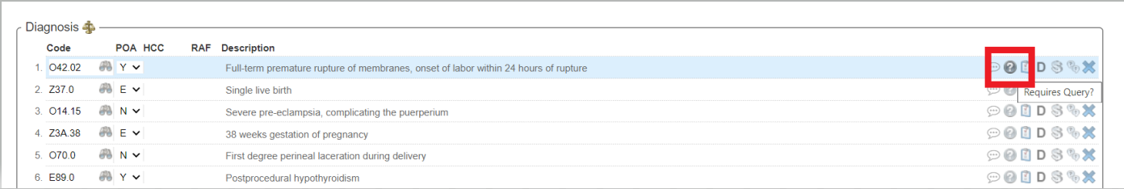

- The coder receives the encounter, sees it is a query, and queries the provider in Epic while leaving the encounter in Coder stage within eValuator.

- Once the coder receives the query back:

  - If there is a change to make, the coder clicks Accept Audit at the bottom of the encounter and updates the codes in Epic.

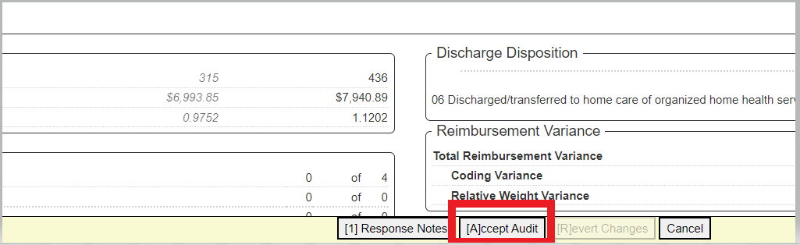

  - If there is no change to make, the coder:
    - Adds a comment using the Response Notes button found at the bottom of the encounter.

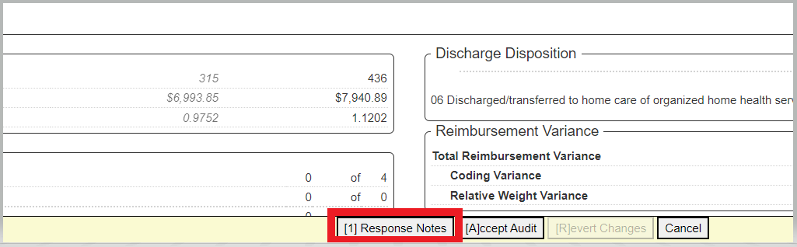

    - Enters their comments in the text box and clicks Save Comments.

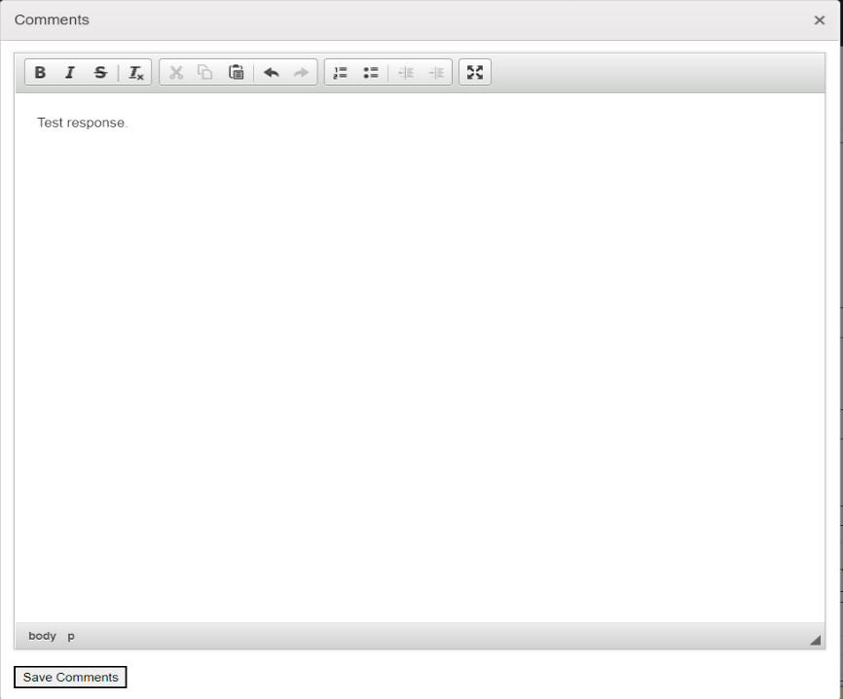

    - Clicks the Send to Audit button found at the bottom of the encounter.

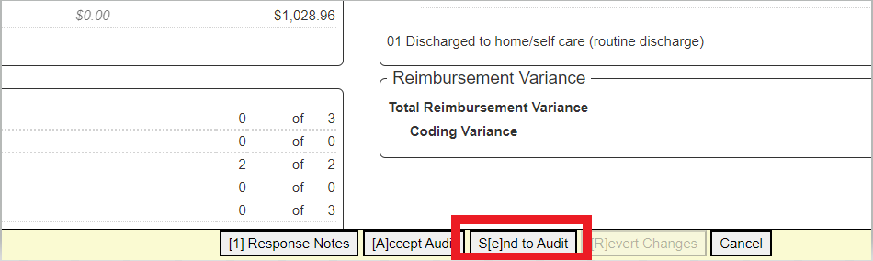
  - Finally, the auditor will then mark the encounter as No Change found at the bottom of the encounter.

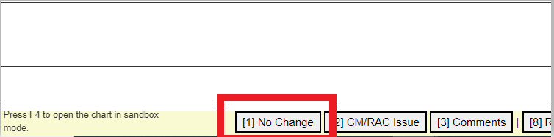

Contact us

If you have any further questions, please contact Streamline Health support: 1-800-878-5269 or open a ticket through our support portal: Streamline Health Client Support Portal.

