EVALUATOR FIRST TIME LOG IN
Accessing eValuator as a new coder or auditor is a 3-step process. Step 1 is accessing eValuator and entering in the provided login credentials. All new users are set up with a generic password of Welcome1.
Step 2 is verification of email address and Step 3 is changing from generic password to a password of the end user’s choice.
Example:
User name: angela.george
Password: Welcome1
Via Chrome (preferred browser) or Edge go to: https://evaluator.streamlinehealth.net/Account/login

1: Coder enters User name and Password (Welcome1) in fields below, and clicks Log in. NOTE: Both fields are case sensitive.

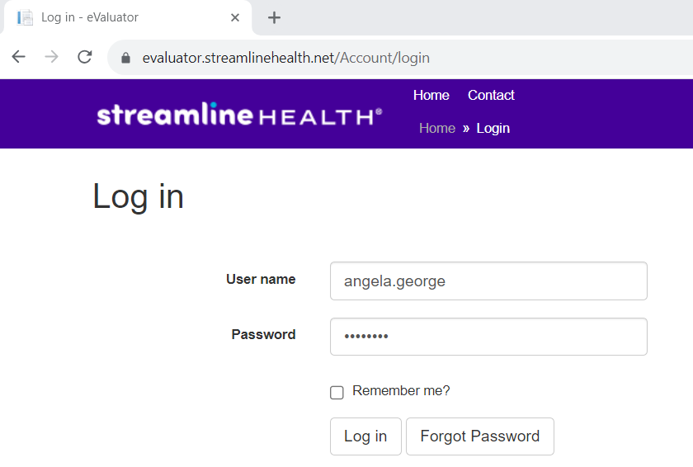

2. After clicking Log in button, screen will redirect to this screen notifying coder that their email must be confirmed before using eValuator.
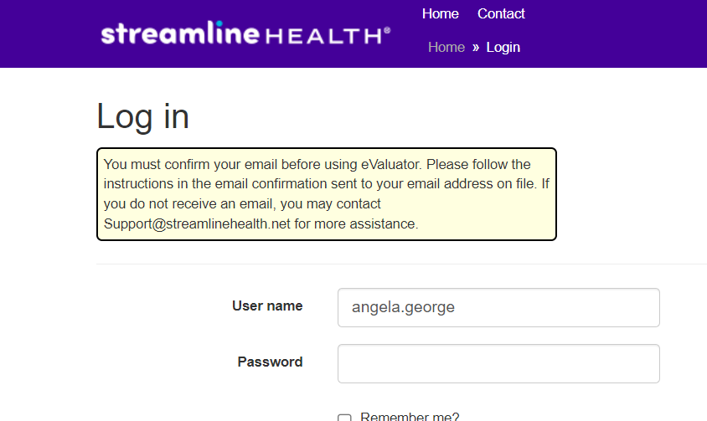
3: Coder must click on the Verify my email address link. NOTE: The From email address is support@streamlinehealth.net Coder should check their spam folder for this email if it doesn’t appear in their inbox.

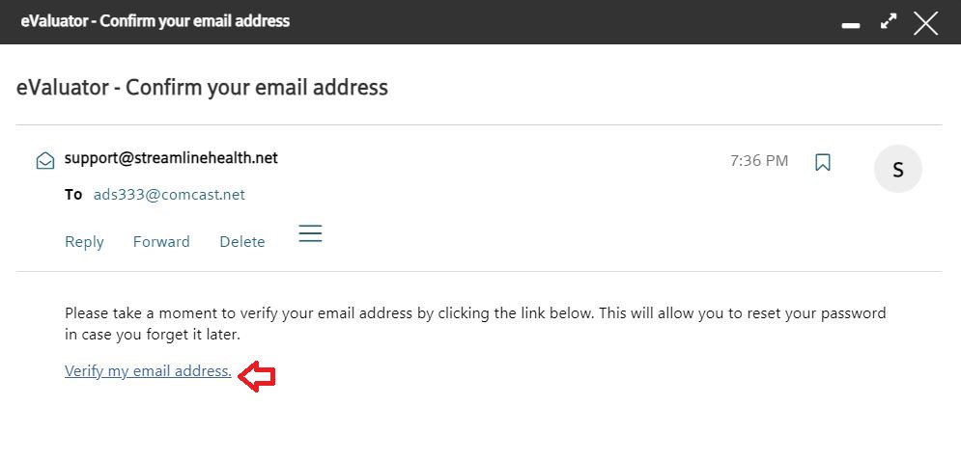
4: Once they click the link, they are then directed to this page which indicates their email address has been confirmed. They need to click Log in in the upper right-hand corner.
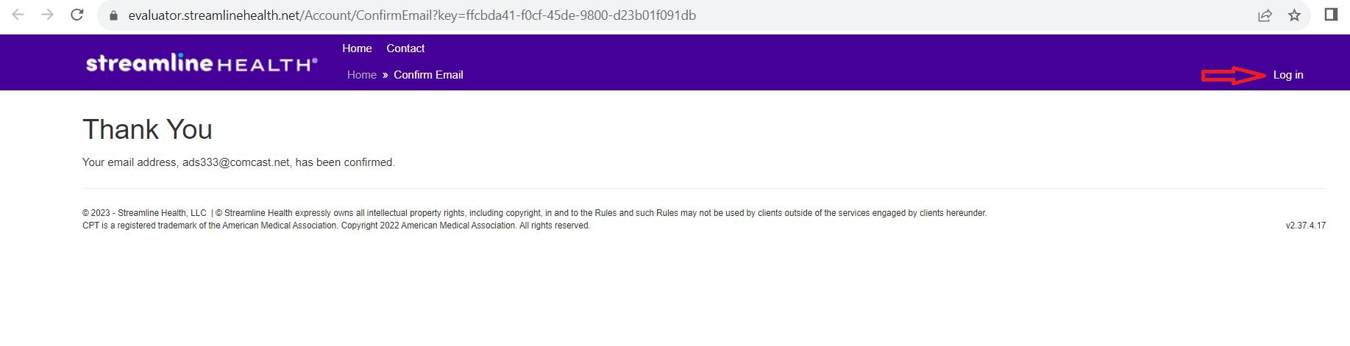

5: Clicking log in as noted above, will then redirect to the page to change the password from Welcome1 to a password of their choice.
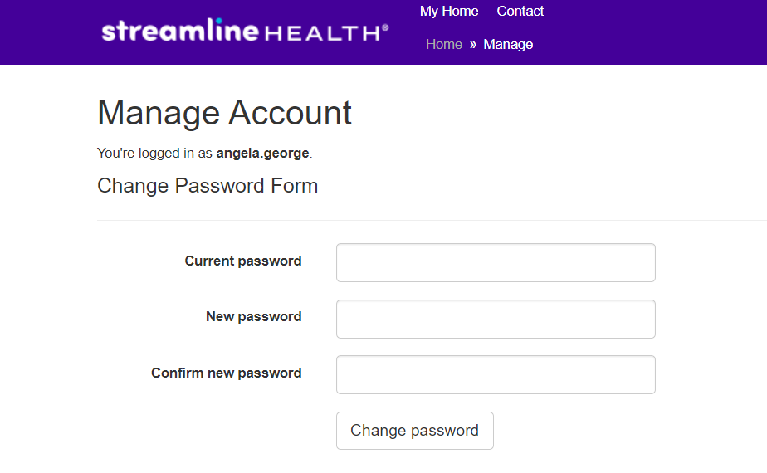
Once these fields are completed, and coder clicks Change password button, coder is automatically logged into eValuator

